|  |  |
| --- | --- |
| Student Name | **Arbab Hussain Qureshi** |
| Roll Number | **22SW028** |
| Section | **01** |

**DBS LAB # 06 – SQL Functions**

**Tasks:**

Q1. Execute the following queries and display their outputs:

i. Display the emp name, salary, and commission for all employees who earn commissions. Sort data in descending order of salary and commissions.

Ans: **SELECT empName, empSal, empComm FROM emp WHERE empComm IS NOT NULL ORDER BY empSal DESC, empComm DESC;**

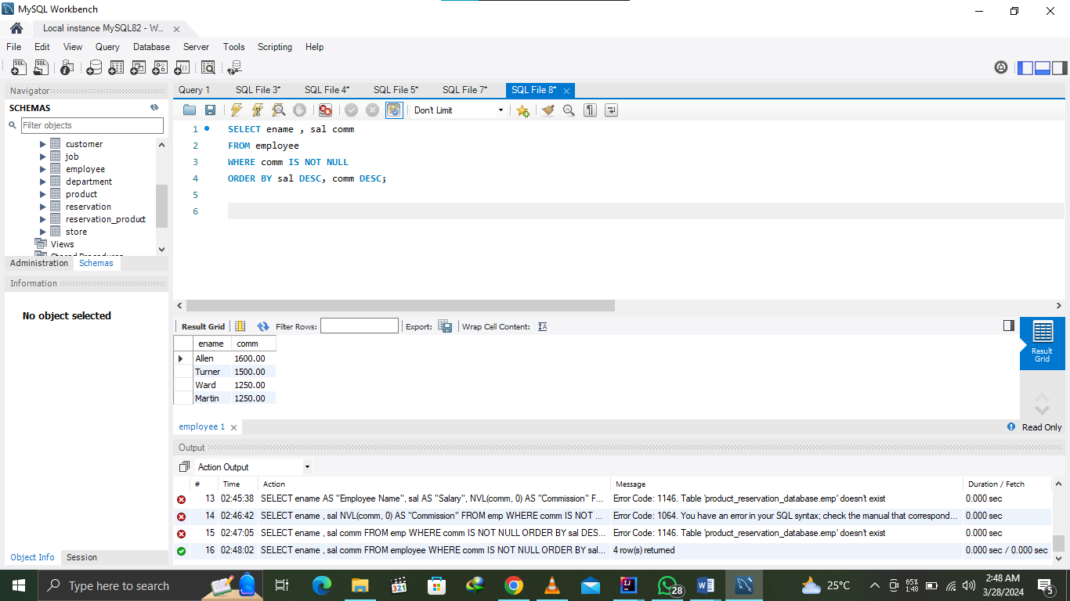Output:

ii)Show empno and ename having deptno 20 or 30 in descending order.

**Ans: SELECT empNo, empName FROM emp WHERE deptNo IN (20,30) ORDER BY empNo DESC;**

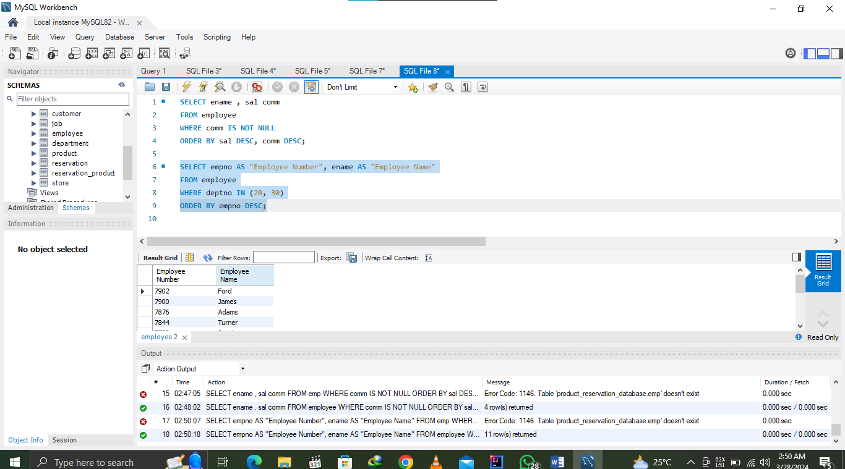Output:

iii. Write a query that displays the employee name (with the first letter uppercase and all other letters lowercase) and the length of the name for all employees whose name starts with the letters J, A, or M. Give each column an appropriate label. Sort the results descending order of the employee name.

Output:

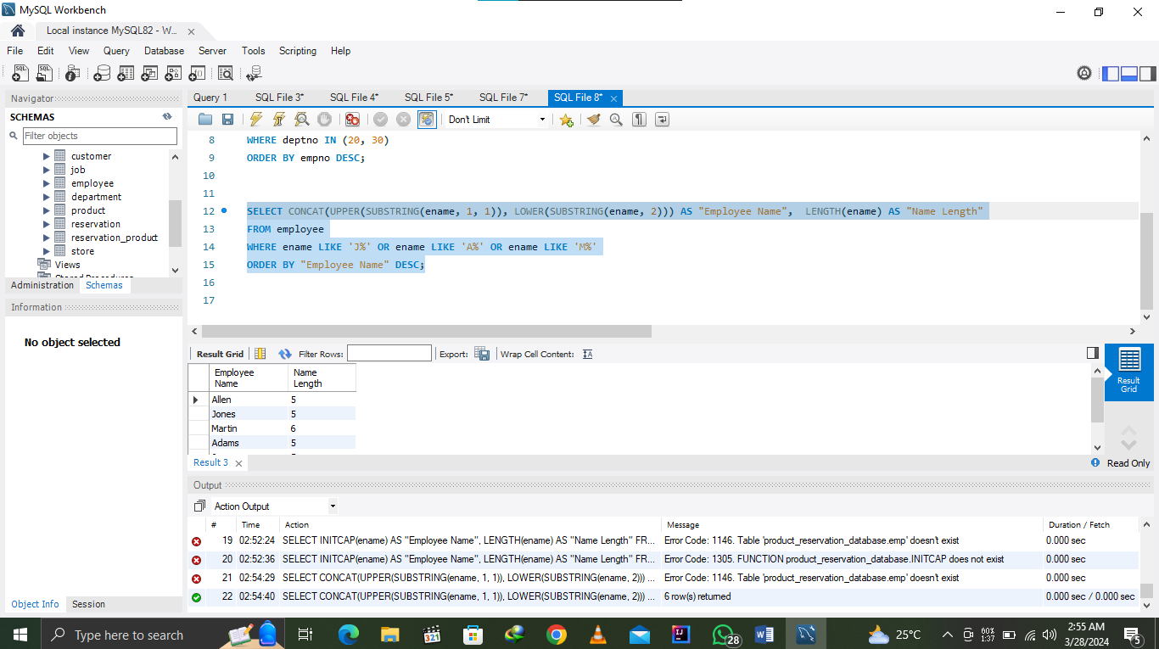

iv. Display the emp name and calculate the number of months between today and the date on which the employee was hired. Label the column MONTHS_WORKED. Order your results in descending order by the number of months employed.

**Ans: SELECT empName, TIMESTAMPDIFF(MONTH, hireDate, CURRDATE()) As Months_Worked FROM employee ORDER BY Months_Worked DESC;**

Output:

v. Display the emp name and salary for all employees. Format the salary to be 15 characters long, left-padded with the “$” symbol. Label the column SALARY.

**Ans: SELECT empName , CONCAT(‘$’, LPAD(empSal, 15, ‘$’)) As “SALARY” FROM emp;**

Output:

vi. Write a query to display the current date. Label the column Date.

**Ans: SELECT CURDATE() As “Date”;**

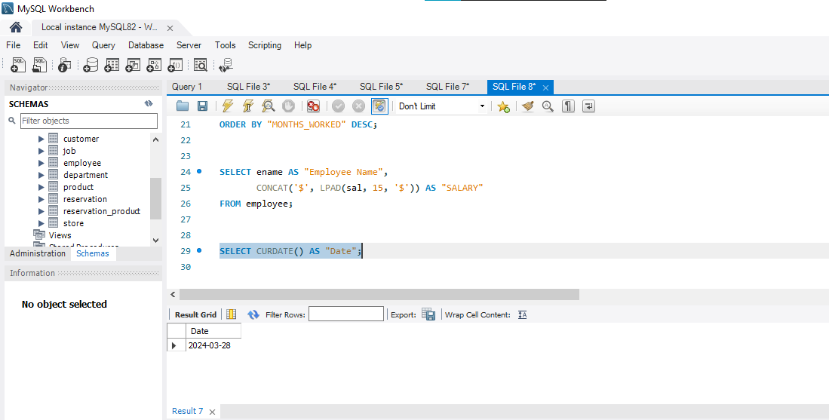Output:

vii. Create a query that displays the employees names and commission amounts. If an employee does not earn commission, show “No Commission.” Label the column COMM. (Hint: Use NVL Function)

**Ans: NVL is used as IFNULL in MySQL**

**SELECT empName, IFNULL(comm,’No Commision’) As ‘COMM’ FROM emp;**

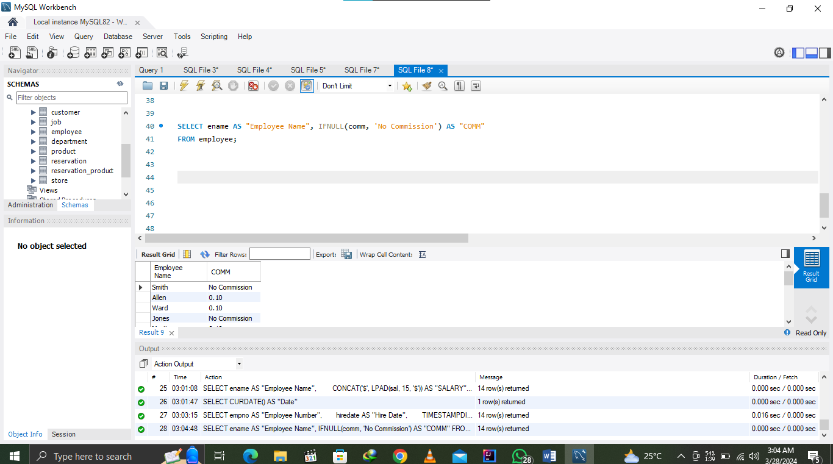Output:

Q2. Run the following queries and display their outputs:

i. Display ename, hiredate and print the date in DD Month YYYY Format. Label the coulmn as “DATE FORMAT”. (Hint: Use To_CHAR Function)

**Ans: SELECT empName As ‘Employee Name’, DATE_FORMAT(hireDate, ‘%d %M %M’) As “DATE FORMAT” FROM emp;**

Output:

